THE FINANCIAL AND ESTATE PLANNING COUNCIL OF METROPOLITAN DETROIT
Presents

Wednesday, September 21, 2022 Dinner Meeting
Skyline Club, 2000 Town Center, Top Floor, Southfield, MI 48075

“Planning for the Sandwich Generation and Beyond”
5:30 pm Cocktails / 6:30 to 7:30 pm Dinner & Presentation

$70.00 per person – Please register online or mail check by 9-2-22:
FEPCMD, 33006 W. Seven Mile Road, #237, Livonia, MI 48152
Name:______________________________ Name: ____________________________________

Elizabeth Forspan, Esq. of Forspan Klear LLP, a New York-based Trusts and Estates law firm, will discuss the important estate planning documents that those in varying stages of life should consider. She will also review elder care and Medicaid planning techniques that advisors and clients should be aware of. Elizabeth will also touch upon the importance of advance planning, particularly with regard to advance directives for those age 18 and above. It will be an interactive and lively discussion.

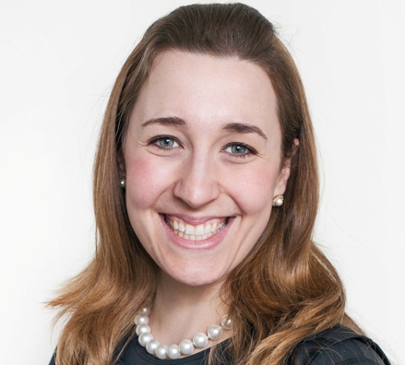

Elizabeth Forspan is a Partner with Forspan Klear LLP, a New York law firm. Elizabeth’s areas of practice include Elder Law, Trusts & Estates and Taxation. Elizabeth speaks throughout the United States on various aspects of Elder Care Planning, Tax Law and Estate Planning. She was the recipient of the prestigious Max Block Award for Outstanding Article in the Category of Technical Analysis, awarded by the New York State Society of Certified Public Accountants’ CPA Journal for her article “Casualty Losses for Property Damaged by Hurricane Sandy”. Elizabeth has been named a Super Lawyers Rising Star in the areas of Estate Planning and Probate in 2016, 2017, 2018, 2019, 2020 and 2021. Elizabeth has been featured in New York Magazine, MarketWatch, and she has been quoted in the New York Times. Prior to co-founding Forspan Klear LLP, Elizabeth was a Tax Manager with Ernst & Young LLP, where she focused on Mergers and Acquisitions and Executive Compensation. Elizabeth earned her Juris Doctor from Fordham University School of Law and her B.A. from Queens College of the City University of New York, where she graduated summa cum laude and is a member of Phi Beta Kappa.

Thank You To Our 2022 Sponsors

BDO Kercheval Financial Group of Wells Fargo Advisors
Berry Moorman Lifetime Financial Growth of Michigan
Butzel Long Maddin Hauser
CIBC Private Wealth Management MassMutual Great Lakes
Clayton & McKervey, PC Merrill Lynch
Community Foundation for SE Michigan MRPR CPAs & Advisors Couzens Lansky Northern Trust
Dawda Mann Northwestern Mutual
Dickinson Wright, PLLC Plante Moran Wealth Management
Doeren Mayhew Plunkett Cooney
Dykema Rehmann
Giarmarco, Mullins & Horton, PC Rochester University
Gordon Advisors Schechter Wealth
Greenleaf Trust Schluter & Hughes Law Firm, PLLC
Hindman Auctioneers Stout
Huntington Private Bank Varnum
Jackson National Warner
Jaffe Williams Williams Ratner & Plunkett, P.C.

