FEPCMD Presents
A Complimentary Webinar

“Considerations in Embarking in
In Vitro Fertilization, Surrogacy, Adoption, and Embryo Donation”

Wednesday, July 29, 2020
11:00 am to Noon EST

Natalia K. Gentry, Esq.
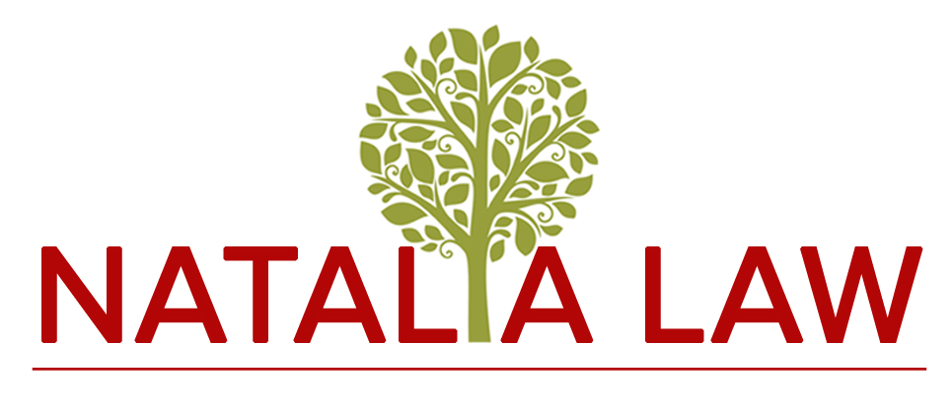
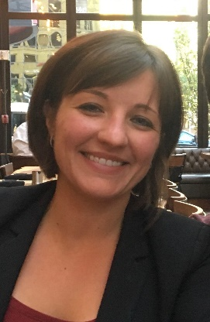

Click Here to Register

NOTE: FEPCMD has chosen Zoom for this event. If you are prevented from using Zoom to attend this event due to company restrictions, please consider joining from a personal computer or cellular phone or by simply dialing in and listening to the event from a telephone. If you will be using a personal device, please test your connection early; an app may need to be downloaded the first time Zoom is used on the new device.

Key Take-Aways
Get to know how it affects your clients when they are or have engaged
in ART (Assisted Reproductive Technology)

Learn why your clients need legal advice in determining the disposition of embryos

Learn about specific estate planning documents covering biological and non-biological children

AGENDA: 11:00 am to Noon EST Presentation followed by brief Q&A

Thank You To Our 2020 Sponsors

BDO Jackson National Berry Moorman Jaffe
Butzel Long Kercheval Financial Group of Wells Fargo Advisors
Chemical Bank Lifetime Financial Growth of Michigan
CIBC Maddin Hauser
Clayton & McKervey, PC Merrill Lynch
Comerica Miller Canfield
Community Foundation for SE Michigan Northern Trust
Comprehensive Planning, Inc. Northwestern Mutual
Couzens Lansky Plante Moran Wealth Management
Dawda Mann Plunkett Cooney
Dickinson Wright, PLLC PLUS Financial Network
Dykema Rehmann
Giarmarco, Mullins & Horton, PC Schechter Wealth
Giroux Amburn, PC Stout
Gordon Advisors Tracy Wick Property Team
Greenleaf Trust Varnum
Hertz Schram, PC Warner
Hindman Auctioneers Wells Fargo Private Bank
Huntington Private Bank Williams Williams Rattner & Plunkett, PC

