THE FINANCIAL AND ESTATE PLANNING COUNCIL OF METROPOLITAN DETROIT
Presents

Tuesday, June 1, 2021
AGENDA:

11:00 am presentation – 11:50 am Q&A

COMPLIMENTARY WEBINAR
REGISTER HERE

Martin M. Shenkman, CPA, MBA, PFS, AEP, JD
Martin M. Shenkman, PC
“What Practitioners Should Be Telling Their Clients Now!”

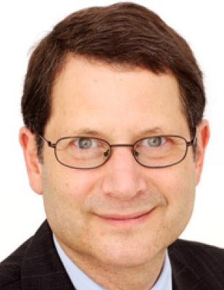
- A massive estate tax bill was introduced by Senator Bernie Sanders on March 25, 2021. This will be a hot topic until we have actual legislation.

- This presentation will cover what’s hot and what’s not in addition to possible or real changes.

- The estate tax legislation landscape is ever-changing, and Mr. Shenkman will provide the most current take at the time of the presentation.
Martin M. Shenkman, CPA, MBA, PFS, AEP (distinguished), JD, is an attorney in private practice in Fort Lee, New Jersey and New York City. His practice concentrates on estate and tax planning, planning for closely held businesses, estate administration. A widely quoted expert on tax matters, Mr. Shenkman is a regular source for numerous financial and business publications, including The Wall Street Journal, Fortune, Money, The New York Times, and others. He has appeared as a tax expert on numerous public and cable television shows including The Today Show, CNN, NBC Evening News, CNBC, MSNBC, CNN-FN, and others. He is a frequent guest on radio talk shows throughout the country and has a regular weekly radio show on Money Matters Financial Network. Mr. Shenkman is a prolific author, having published 42 books and more than 1,000 articles.
Mr. Shenkman received his Bachelor of Science degree from Wharton School, with a concentration in accounting and economics. He received a Masters degree in Business Administration from the University of Michigan, with a concentration in tax and finance. He received his law degree from Fordham University School of Law, and is admitted to the bar in New York, New Jersey and Washington, D.C. He is a Certified Public Accountant in New Jersey, Michigan and New York. He is a registered Investment Advisor in New York and New Jersey.

Thank You To Our 2021Sponsors

BDO Jaffe Berry Moorman Kercheval Financial Group of Wells Fargo Advisors
Butzel Long Lifetime Financial Growth of Michigan
Clayton & McKervey, PC Maddin Hauser
Comerica Merrill Lynch Community Foundation for SE Michigan Miller Canfield
Couzens Lansky Northern Trust
Dawda Mann Northwestern Mutual
Dickinson Wright, PLLC Plante Moran Wealth Management
Dykema Plunkett Cooney
Giarmarco, Mullins & Horton, PC Rehmann
Gordon Advisors Rochester University
Greenleaf Trust Schechter Wealth
Hertz Schram, PC Varnum
Hindman Auctioneers Warner
Huntington Private Bank Wells Fargo Private Bank
Jackson National Williams Williams Ratner & Plunkett, P.C.

