THE FINANCIAL AND ESTATE PLANNING COUNCIL OF METROPOLITAN DETROIT
Presents

Tuesday, May 9, 2023 Next Gen Topgolf Event (age 40 & under)
4:00 pm to 6:00 pm

Topgolf, 500 Great Lakes Crossing Dr, Auburn Hills, MI 48326

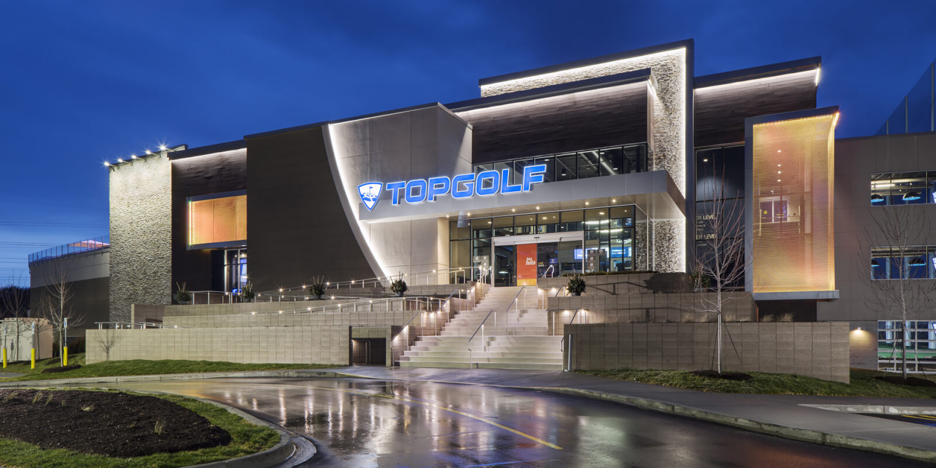

$30.00 per person includes:
Golf, team building relay race hosted by Topgolf, 1 shared food item per bay & 1 drink per person
(individual tabs will be set up after the FEPCMD subsidy has been reached)

Please register online or mail check by 4-15-23:
FEPCMD, 33006 W. Seven Mile Road, #237, Livonia, MI 48152
Questions: Please call 313-530-9223 or email fepcmd@associationoffice.org

Name:_________________________ Email:____________________Phone:________________

Guest:_________________________ Email:____________________Phone:________________

So what is Topgolf? In short, they are a sports entertainment complex that features an inclusive, high-tech golf game that everyone can enjoy. Paired with an outstanding food and beverage menu, climate-controlled hitting bays and music, every Topgolf has an energetic hum that you can feel right when you walk through the door.

Final Thank You To Our 2023 Sponsors

BDO Jaffe has joined Taft Berry Moorman Kercheval Financial Group of Wells Fargo Advisors
Butzel Long Lifetime Financial Growth of Michigan
CIBC Private Wealth Management LoVasco Consulting Group
Clayton & McKervey, PC Maddin Hauser
Couzens Lansky MassMutual Great Lakes
Dawda Mann MRPR CPAs & Advisors
Dickinson Wright, PLLC Northern Trust Doeren Mayhew Northwestern Mutual
Dykema Plante Moran Wealth Management
Giarmarco, Mullins & Horton, PC Plunkett Cooney
Giroux Pappas Trial Attorneys Principal Financial
Gordon Advisors Pugh Moak P.C.
Greenleaf Trust Rehmann
Hindman Auctioneers Schluter & Hughes Law Firm, PLLC
Huntington Private Bank Varnum
Jackson National Warner

