THE FINANCIAL AND ESTATE PLANNING COUNCIL OF METROPOLITAN DETROIT
Presents

Wednesday, April 28, 2021
AGENDA:

11:00 am presentation – 11:50 am Q&A

COMPLIMENTARY WEBINAR

REGISTER HERE

Pamela Lucina, Northern Trust
“Thoughtful and Experienced Trustees: Lessons Learned
From Guiding Families Through Uncertainty”

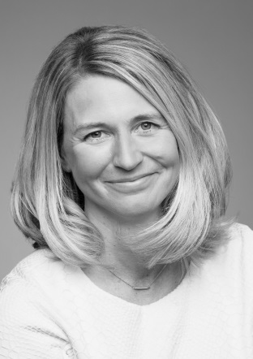
The COVID-19 pandemic is said to be the most severe global crisis since World War II. Through it all, advisors have served as strong foundations for families as they navigate difficult personal, social, and financial challenges during cataclysmic events. During these trying times, trusts and trustees have demonstrated that, besides managing the orderly transfer and management of wealth, they can offer enduring, but flexible frameworks to deliver expert counsel. Using real-life examples, this session will highlight some of the behavioral biases trustees and advisors regularly confront. The discussion will address how having data and a framework helps clients steer through crises and will provide lessons for navigating future uncertainty.

Prior to joining Northern, Pam was with BNY Mellon where she held the national role of Executive Director for their Wealth Management Advice, Planning and Fiduciary Services practice. Before that she was with JPMorgan providing wealth and estate planning services, and also spent 10 years in private practices as a tax consultant with Arthur Andersen, and in the trusts and estates departments of both Levin Schroeder and Mayer Brown law firms. Pam earned her bachelor’s degree from Marquette University in Business Administration and Management (BS) and her Doctor of Law (JD), Taxation from DePaul University.
She is a Fellow of the American College of Trust and Estate Counsel (ACTEC). Pam is a member of the Northern Trust’s Wealth Management Executive Leadership Team. This group oversees the direction of our Wealth Management Business. Pam has a strong background in wealth, tax, philanthropic and business owner planning, she also brings expertise in next generation education, governance and global family office matters. She is a recognized leader and speaker within the Estate and Trust legal community.

Thank You To Our 2021Sponsors
BDO Berry Moorman Jaffe
Butzel Long Kercheval Financial Group of Wells Fargo Advisors
CIBC Lifetime Financial Growth of Michigan
Clayton & McKervey, PC Maddin Hauser Comerica Merrill Lynch
Community Foundation for SE Michigan Miller Canfield
Couzens Lansky Northern Trust
Dawda Mann Northwestern Mutual
Dickinson Wright, PLLC Plante Moran Wealth Management
Dykema Plunkett Cooney
Giarmarco, Mullins & Horton, PC Rehmann
Gordon Advisors Rochester University
Greenleaf Trust Schechter Wealth
Hertz Schram, PC Varnum
Hindman Auctioneers Warner
Huntington Private Bank Wells Fargo Private Bank
Jackson National Williams Williams Ratner & Plunkett, P.C.

