THE FINANCIAL AND ESTATE PLANNING COUNCIL OF METROPOLITAN DETROIT
Presents

Wednesday, April 27, 2022 Dinner Meeting
Skyline Club, 2000 Town Center, Top Floor, Southfield, MI 48075

“Pre and Post Nuptial Agreements: Not just for the Rich and Famous”
5:30 pm Cocktails / 6:30 to 7:30 pm Dinner & Presentation
$70.00 per person – Please register online or mail check by 4-12-22:
FEPCMD, 33006 W. Seven Mile Road, #237, Livonia, MI 48152
Name:______________________________ Name: ____________________________________

First there were Pre-nups, then there were Post-nups and now there are No-nups. Join us as we discuss the rise of the Millennial pre-nup, trends with later-in-life marriages, and the reappearance of the no-nup. We will also discuss some financial and estate planning considerations for estate planning professionals working with clients bound by one of these documents.

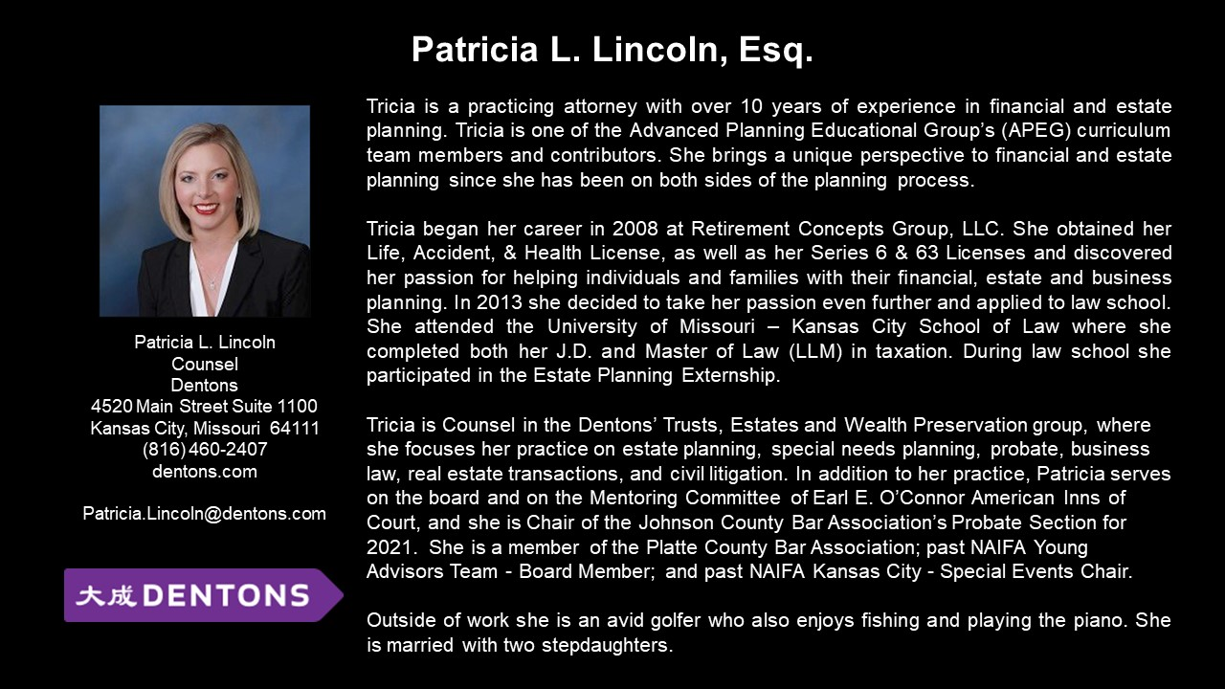 Thank You To Our 2022 Sponsors

BDO Lifetime Financial Growth of Michigan Berry Moorman Maddin Hauser
Butzel Long MassMutual Great Lakes
CIBC Private Wealth Management Merrill Lynch
Clayton & McKervey, PC MRPR CPAs & Advisors
Community Foundation for SE Michigan Northern Trust Couzens Lansky Northwestern Mutual
Dawda Mann Plante Moran Wealth Management
Dickinson Wright, PLLC Plunkett Cooney
Doeren Mayhew Rehmann
Dykema Rochester University
Giarmarco, Mullins & Horton, PC Schechter Wealth
Gordon Advisors Schluter & Hughes Law Firm, PLLC
Greenleaf Trust Stout
Hindman Auctioneers Varnum
Huntington Private Bank Warner
Jackson National Wells Fargo Private Bank
Jaffe Williams Williams Ratner & Plunkett, P.C.
Kercheval Financial Group of Wells Fargo Advisors

