THE FINANCIAL AND ESTATE PLANNING COUNCIL OF METROPOLITAN DETROIT
Presents

Tuesday, March 29, 2022 / 11:00 am to Noon ET
Complimentary Virtual Webinar

“Boilerplate Traps: Helpful Tips For
Drafting and Administration of Trusts”
Wendy Z. Cox, J.D., CTFA
Senior Vice President, Director of Personal Trust and Fiduciary Officer
Register Here

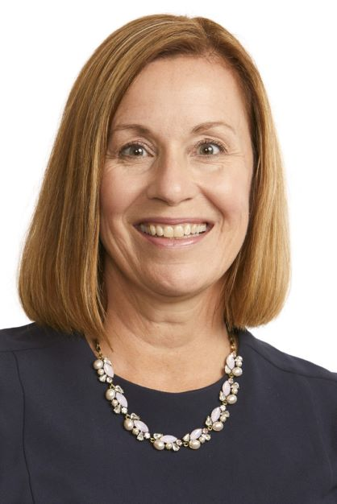
Presentation Outcomes
- Co-fiduciaries: The Good and the Bad
- Non-traditional Assets Held in Trust—Issues to Consider
- Considerations in Drafting Distribution Standards
- Beneficiary Complications

Wendy’s responsibilities include providing a trust perspective to all wealth management discussions, and coordinating planning strategies with other professional advisors, such as tax advisors or estate planning attorneys. She is also responsible for day-to-day account oversight, fiduciary compliance and directing our team of trust relationship officers to ensure our clients receive remarkable service. Wendy practiced law for 16 years in the areas of probate and trust litigation, complex probate and trust administration, preparation of estate, fiduciary and gift tax returns, and drafting estate planning and business succession documents. She earned her B.A. and J.D. from the University of Michigan. Wendy is a designated Certified Trust and Fiduciary Advisor.
Thank You To Our 2022 Sponsors

BDO Lifetime Financial Growth of Michigan Berry Moorman Maddin Hauser
Butzel Long MassMutual Great Lakes
CIBC Private Wealth Management Merrill Lynch
Clayton & McKervey, PC MRPR CPAs & Advisors
Community Foundation for SE Michigan Northern Trust Couzens Lansky Northwestern Mutual
Dawda Mann Plante Moran Wealth Management
Dickinson Wright, PLLC Plunkett Cooney
Doeren Mayhew Rehmann
Dykema Rochester University
Giarmarco, Mullins & Horton, PC Schechter Wealth
Gordon Advisors Schluter & Hughes Law Firm, PLLC
Greenleaf Trust Stout
Hindman Auctioneers Varnum
Huntington Private Bank Warner
Jackson National Wells Fargo Private Bank
Jaffe Williams Williams Ratner & Plunkett, P.C.
Kercheval Financial Group of Wells Fargo Advisors

