THE FINANCIAL AND ESTATE PLANNING COUNCIL OF METROPOLITAN DETROIT
Presents

Thursday, March 2, 2023 Dinner Meeting
The Whiskey Factory, 1000 Maple Street, Detroit, MI 48207
(complimentary onsite & guarded parking)

“The Evolving 401(k) Plan Landscape -
What Professionals Advising Business Owners Need to Know”
Rickie Taylor, Retirement Plan Consultants

5:30 pm to 6:00 pm / Optional Tour & Whiskey/Rye Tasting – Tour Limit: 30 - $15 per person
(Please arrive by 5:15 if you wish to have a drink from the bar during the tour)
5:15 pm to 6:30 pm / Cocktail Hour+
6:30 pm to 7:30 pm / Presentation & Dinner (bar will close at 7:15 pm)
Pending: CFP® CE Offered by our partner, APEG

$70.00 per person – cocktails, dinner, presentation – complimentary parking
$15.00 per person – optional 30 minute tour & whiskey tasting during cocktail hour
– Please register online or mail check by 2-17-23:
FEPCMD, 33006 W. Seven Mile Road, #237, Livonia, MI 48152
Name:______________________________ Guest: ____________________________________
- With more States mandating that employers establish 401(k) plans for their employees, professionals need to know how to help their business-owner clients avoid common pitfalls.

- Further complicating matters, the recent passage of Secure 2.0 has left business-owners with more questions than answers.

- Join our guest speaker, Rickie Taylor, as he efficiently walks us through this ever evolving and complicated world.

Rickie Taylor is a Regional Director for Retirement Plan Consultants (RPC). Rickie is responsible for 401(k)/Qualified Plan consulting and business development initiatives in partnership with financial advisors, CPAs, lawyers and payroll providers. Prior to joining RPC, Rickie spent over 15 years as a local Third Party Administrator. Rickie was a dedicated resource to the plans he serviced with great knowledge of the plan’s operations and one phone call attitude. Rickie started his career at New York Life Investment Management where he worked with retirement plans and was part of the marketing group for the upstart 529 plan. Rickie is the First Vice Chair of the Association of African-American Financial Advisors. In his spare time, Rickie enjoys cooking and working out to counter the effects of his love of cooking.

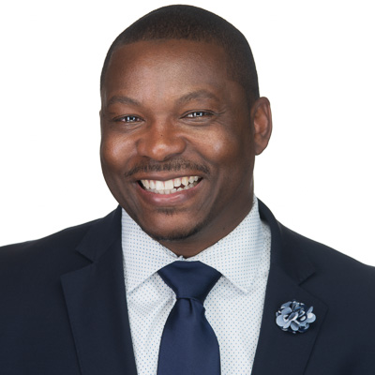

Final Thank You To Our 2022 Sponsors
BDO Kercheval Financial Group of Wells Fargo Advisors
Berry Moorman Lifetime Financial Growth of Michigan
Butzel Long Maddin Hauser
CIBC Private Wealth Management MassMutual Great Lakes
Clayton & McKervey, PC Merrill Lynch
Community Foundation for SE Michigan MRPR CPAs & Advisors Couzens Lansky Northern Trust
Dawda Mann Northwestern Mutual
Dickinson Wright, PLLC Plante Moran Wealth Management
Doeren Mayhew Plunkett Cooney
Dykema Rehmann
Giarmarco, Mullins & Horton, PC Rochester University
Gordon Advisors Schechter Wealth
Greenleaf Trust Schluter & Hughes Law Firm, PLLC
Hindman Auctioneers Stout
Huntington Private Bank Varnum
Jackson National Warner
Jaffe Williams Williams Ratner & Plunkett, P.C.

Welcome to Our New 2023 Sponsors
LoVasco Consulting Group Principal Financial
Pugh Moak. P.C.

