THE FINANCIAL AND ESTATE PLANNING COUNCIL OF METROPOLITAN DETROIT
Presents

Wednesday, February 23, 2022 / 1:00 pm to 2:00 pm ET
Complimentary Virtual Webinar

“Taxes: What’s New in 2022”
Ruth Flynn Raftery, JD, CPA, AEP®
Register Here

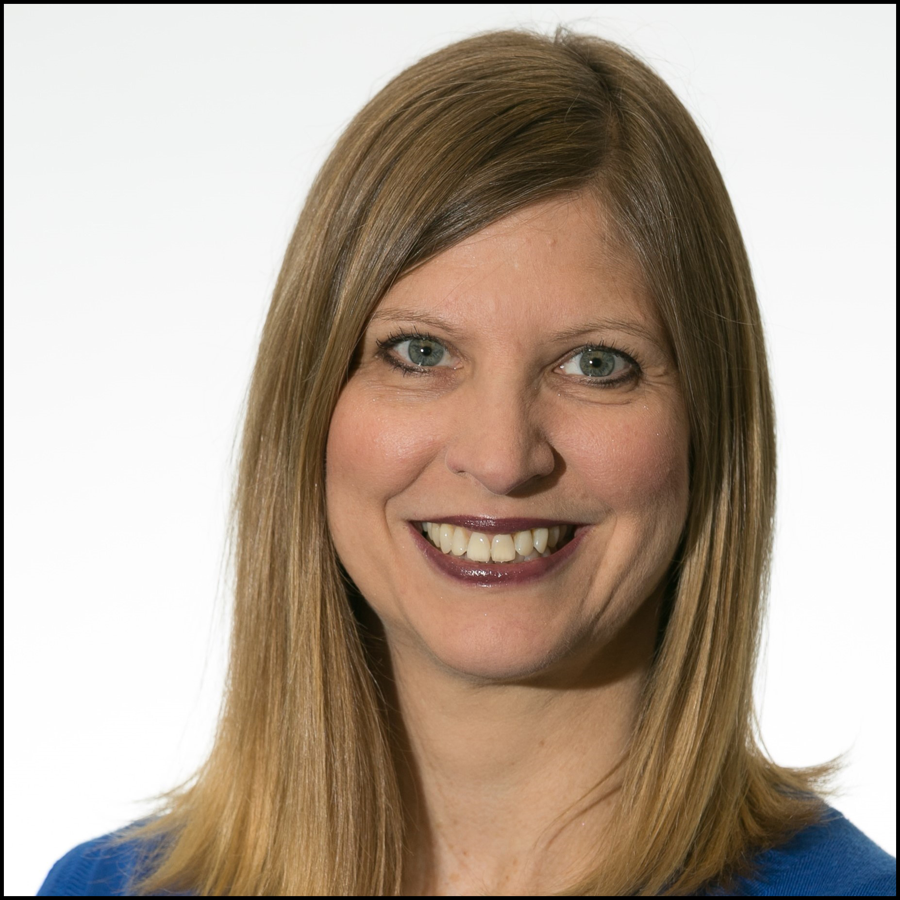
2021 looked like it would be the year for sweeping tax law changes. But, even though the Democrats held the White House and both Houses of Congress, that didn’t happen. Currently, debate continues about a scaled-back version of the Budget Reconciliation Bill (aka – The Build Back Better Act) and accountants are busy with the 2021 tax filing season. In this webinar we’ll discuss:
- What’s New in 2022
- What didn’t happen
- What might still happen
- General tax planning ideas
- Taxes and collaboration among members in the Financial and Estate Planning Council

Ruth is a licensed attorney and a Certified Public Accountant with over 20 years of experience. As President and co-founder of Advanced Planning Educational Group (APEG), Ruth is responsible for creating and executing the design and strategic direction of APEG’s mission to support the needs of professionals who participate in the holistic planning process. In addition to her role with APEG, Ruth also serves as a Senior Advisor to AltaView Advisors, LLC a business valuation firm with offices in Orange County, San Francisco, Dallas and New York. Throughout her career, Ruth has held a variety of roles both within and outside of Public Accounting. Early in her career, she spent 12 years in the Tax Department at Deloitte, and most recently, was employed as a Director in the Estate, Gift and Trust Services Group at Wiss & Company LLP, a public accounting firm with offices in New York and New Jersey. Her expertise in both US and International estate, gift and trust taxation allowed her to serve clients including owners of closely held businesses, high net-worth individuals and families, and individuals who serve as fiduciaries for estates and trusts. In roles outside of public accounting, Ruth led Product Development for tax products at Thomson Reuters, was the Director of Business Development at FMV Opinions and participated in the planning process as a Wealth Advisor at Round Table Wealth Management. Ruth’s diverse experience gives her a unique perspective into to the role that various professionals play in the holistic planning process.
A Final Thank You To Our 2021Sponsors
BDO Jaffe Berry Moorman Kercheval Financial Group of Wells Fargo Advisors
Butzel Long Lifetime Financial Growth of Michigan
Clayton & McKervey, PC Maddin Hauser
Comerica Merrill Lynch Community Foundation for SE Michigan Miller Canfield
Couzens Lansky Northern Trust
Dawda Mann Northwestern Mutual
Dickinson Wright, PLLC Plante Moran Wealth Management
Dykema Plunkett Cooney
Giarmarco, Mullins & Horton, PC Rehmann
Gordon Advisors Rochester University
Greenleaf Trust Schechter Wealth
Hindman Auctioneers Varnum
Huntington Private Bank Warner
Jackson National Wells Fargo Private Bank
Williams Williams Ratner & Plunkett, P.C.
Welcome New 2022 Sponsors
CIBC Private Wealth Management Doeren Mayhew
MassMutual Great Lakes MRPR CPAs & Advisors
Schluter & Hughes Law Firm, PLLC Stout

