THE FINANCIAL AND ESTATE PLANNING COUNCIL OF METROPOLITAN DETROIT
Presents

MONDAY, OCTOBER 26, 2020

AGENDA:

11:00 am presentation – 11:50 am Q&A

COMPLIMENTARY WEBINAR

REGISTER HERE

Sara Schimke, JD
“Special Needs Planning 2020”

- Special Needs Planning Best Practices

- Techniques in Special Need Planning Language

- Potential changes to ABLE Accounts

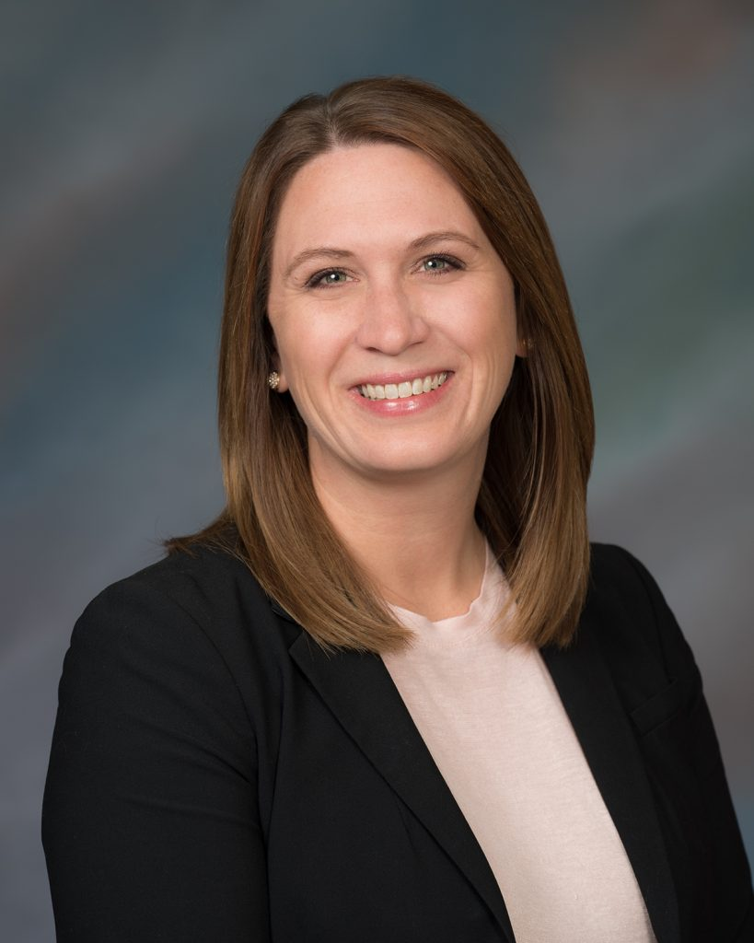

Sara Schimke practices in the areas of long-term care planning and advocacy, as well as probate litigation and financial exploitation. Sara is the immediate past Chair of the Elder Law and Disability Rights Section of the Michigan State Bar, and has served on the Section Council for nine years. She is a member of the ICLE Elder Law advisory board and an adjunct professor at Western Michigan University Thomas M. Cooley Law School, where she was a pioneer member of the Thomas M. Cooley Auburn Hills Estate Planning Clinic. She is also an accredited attorney with the Department of Veterans Affairs, a member of the National Academy of Elder Law Attorneys, a member of the Financial & Estate Planning Council of Metro Detroit and on the Board of Directors and speaker for the Michigan Parkinson Foundation.
Ms. Schimke went to Cooley Law School, and has been licensed to practice law in Michigan since 2008.
Thank You To Our 2020 Sponsors
BDO Jackson National Berry Moorman Jaffe
Butzel Long Kercheval Financial Group of Wells Fargo Advisors
Chemical Bank Lifetime Financial Growth of Michigan
CIBC Maddin Hauser
Clayton & McKervey, PC Merrill Lynch
Comerica Michigan Financial Companies
Community Foundation for SE Michigan Miller Canfield
Comprehensive Planning, Inc. Northern Trust
Couzens Lansky Northwestern Mutual
Dawda Mann Plante Moran Wealth Management
Dickinson Wright, PLLC Plunkett Cooney
Dykema PLUS Financial Network
Giarmarco, Mullins & Horton, PC Rehmann
Giroux Trial Attorneys Schechter Wealth
Gordon Advisors Stout
Greenleaf Trust Tracy Wick Property Team
Hertz Schram, PC Varnum
Hindman Auctioneers Warner
Huntington Private Bank Wells Fargo Private Bank
Williams Williams Rattner & Plunkett, PC

