THE FINANCIAL AND ESTATE PLANNING COUNCIL OF METROPOLITAN DETROIT
Presents

Wednesday, October 12, 2022 Breakfast Meeting
Skyline Club, 2000 Town Center, Top Floor, Southfield, MI 48075

“Life Insurance as an Asset – Maximizing Value for Planning”
Jamie L. Mendelsohn, Executive Vice President

8:30 am to 9:00 am Breakfast Buffet / 9:00 am to 9:40 am Presentation
9:40 am to 10:00 am Q&A and Additional Networking

$25.00 per person – Please register online or mail check by 10-5-22:
FEPCMD, 33006 W. Seven Mile Road, #237, Livonia, MI 48152
Name:______________________________ Name: ____________________________________
Life insurance is a mainstay in estate and business succession/buy-sell planning. As circumstances change, advisors and clients can appropriately value and potentially monetize policies for more than their cash surrender value. The valuation of existing policies reveals unrecognized asset value to help solve immediate financial planning needs. The presentation will include retirement planning solutions, business management solutions, estate planning solutions, tax planning solutions, ILIT management solutions, wealth management solutions, and will include life settlement best practices.

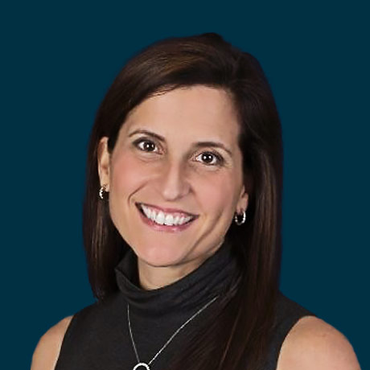

Jamie L. Mendelsohn is the Executive Vice President of Ashar Group – a family-owned business with a national footprint. Since 2003, they have focused solely on the life settlement and life insurance policy valuation market. Ashar Group partners with financial professionals, fiduciaries, broker-dealers, and institutions serving as an independent advanced planning resource in the secondary market for life insurance. Throughout her tenure at Ashar Group, Jamie has earned the reputation of a determined client advocate. She is the go-to resource for advanced planners and fiduciaries who integrate life insurance policy valuation into their planning process. If the decision is made to sell the policy as a life settlement, she negotiates with licensed buyers on behalf of their clients. Jamie speaks nationally at financial services conferences and estate planning councils. Jamie earned her bachelor’s and master’s degrees from the University of Florida. She is a proud member of Women in Insurance and Financial Services. Jamie dedicates much of her time and energy to the Crohn’s and Colitis Foundation where she mentors patients and families while serving as the President of the Central FL/North FL Chapter.

Thank You To Our 2022 Sponsors

BDO Kercheval Financial Group of Wells Fargo Advisors
Berry Moorman Lifetime Financial Growth of Michigan
Butzel Long Maddin Hauser
CIBC Private Wealth Management MassMutual Great Lakes
Clayton & McKervey, PC Merrill Lynch
Community Foundation for SE Michigan MRPR CPAs & Advisors Couzens Lansky Northern Trust
Dawda Mann Northwestern Mutual
Dickinson Wright, PLLC Plante Moran Wealth Management
Doeren Mayhew Plunkett Cooney
Dykema Rehmann
Giarmarco, Mullins & Horton, PC Rochester University
Gordon Advisors Schechter Wealth
Greenleaf Trust Schluter & Hughes Law Firm, PLLC
Hindman Auctioneers Stout
Huntington Private Bank Varnum
Jackson National Warner
Jaffe Williams Williams Ratner & Plunkett, P.C.

