THE FINANCIAL AND ESTATE PLANNING COUNCIL OF METROPOLITAN DETROIT
Presents

Thursday, January 27, 2022
The Skyline Club, 2000 Town Center, Southfield, MI 48075
Douglas J. Van Der Aa, CPA, JD

“COVID-Free (?) Federal Tax Update”

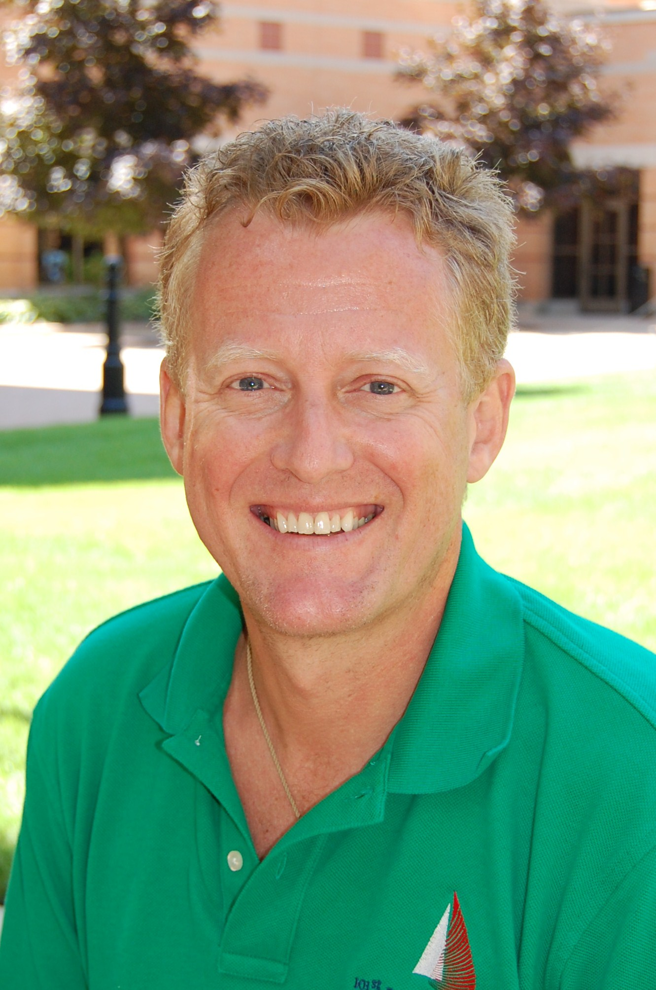

It's been a crazy tax ride the last two years - and it isn't going to settle down any time soon! Get ready for a lively and fast paced look at current tax changes impacting tax and estate planning, including:
- COVID-related Tax Relief Act of 2020
- American Rescue Plan Act of 2021
- (Bipartisan) Infrastructure Investment and Jobs Act (including crypto reporting); and maybe
- Build Back Better Act (pending)

Doug is a lively and energetic speaker—especially on the subjects of taxes and ethics. He has been a highly-rated speaker and seminar leader for CPA associations and other organizations throughout the country for more than 15 years. He has more than 25 years of professional experience in both CPA firms and law firms. For over 12 years, Doug taught accounting and tax courses at the undergrad and MST levels for Grand Valley State University, Hope College, and Davenport University, and has served as a speaker for the Michigan Association of CPAs. Follow Doug on Twitter and Facebook !Twitter: @AaTaxedFacebook: ttps://www.facebook.com/vanderaataxed/
AGENDA: 5:30 p.m. Complimentary Cocktails / 6:30 p.m. Presentation and Dinner
~~~~~~~~~~~~~~~~~~~~~~~~~~~~~~~~~~~~~~~~~~~~~~~~~~~~~~~~~~~~~~~~~~~~~~~~~~~~~~~~~~~~~~~~~~~~
REGISTER ONLINE HERE COST: $70.00 PER PERSON

OR PLEASE MAIL YOUR RESERVATION AND CHECK TO:
FEPCMD ● 33006 W. Seven Mile Road, #237 ● Livonia, MI 48152
Phone: (313) 530-9223 ● Fax: (248) 479-0350 ● Website: https://www.metrodetroitfepc.org/

MEMBER NAME: ____________________________________ GUEST NAME: ______________________________________
TOTAL ENCLOSED: ____________________________________ SPECIAL MEAL REQUESTS:___________________________
A Final Thank You To Our 2021Sponsors
BDO Jaffe Berry Moorman Kercheval Financial Group of Wells Fargo Advisors
Butzel Long Lifetime Financial Growth of Michigan
Clayton & McKervey, PC Maddin Hauser
Comerica Merrill Lynch Community Foundation for SE Michigan Miller Canfield
Couzens Lansky Northern Trust
Dawda Mann Northwestern Mutual
Dickinson Wright, PLLC Plante Moran Wealth Management
Dykema Plunkett Cooney
Giarmarco, Mullins & Horton, PC Rehmann
Gordon Advisors Rochester University
Greenleaf Trust Schechter Wealth
Hindman Auctioneers Varnum
Huntington Private Bank Warner
Jackson National Wells Fargo Private Bank
Williams Williams Ratner & Plunkett, P.C.
Welcome New 2022 Sponsors
Hughes Law Firm, PLLC MassMutual Great Lakes

