[](http://fpami.com/index.php?bypassCookie=1)  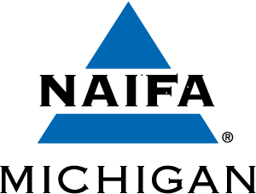 [](http://www.metrodetroitfepc.org/) 

**Five Organizations Come Together To Present**

**“FBI Shares Current Fraud Scandals”**

**Tuesday, October 8, 2019**

**SA John Horwath**

**FBI Detroit Division**

**Complex Financial Crimes Program**

**Ukrainian Cultural Center**

**(PLEASE NOTE NEW VENUE!)**

**26601 Ryan Road, Warren, MI 48091**

***Presentation Outcomes:***

* ***What will the attendee learn?***
* ***The current frauds and swindles that target the elder demographic and why the elderly are targeted.***

* ***What’s the presentation take-away?***
* ***Criminals exploit the aging process to take advantage of the elderly. Attendees should independently verify authenticity before engaging in any transactions.***
* ***Why should you attend this event?***
* ***To learn practices that will help mitigate financial exploitation by criminals.***

**AGENDA: 10:30 a.m. – 11: 15 a.m. Registration & Optional Networking**

**11:20 a.m. Family Style Dining**

**11:30 a.m. – 12:30 p.m. Presentation – Q&A**

~~~~~~~~~~~~~~~~~~~~~~~~~~~~~~~~~~~~~~~~~~~~~~~~~~~~~~~~~~~~~~~~~~~~~~~~~~~~~~~~~~~~~~~~~~

***Log onto our website by October 1 to make your reservation and pay with VISA or Master Card.***

[**www.metrodetroitfepc.org**](http://www.metrodetroitfepc.org)

**OR PLEASE MAIL YOUR RESERVATION AND CHECK BY October 1 TO:** **COST: $15.00 PER PERSON**

**FEPCMD** ● **33006 W. Seven Mile Road, #237** ● **Livonia, MI 48152**

**Phone: (313) 530-9223 ●** **Fax: (248) 479-0350**

### MEMBER NAME: ______________________________ COMPANY NAME: ______________________________________

**GUEST NAME: ____________________________________TOTAL ENCLOSED: _____________________________________**